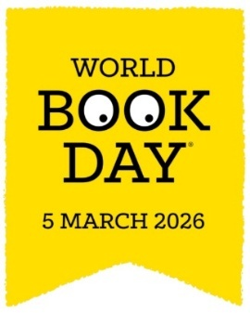
World Book Day
Thursday 5th March 2026
Put 5th March 2026 in your diary for World Book Day 2026! World Book Day champions reading for fun – that’s because it seriously improves lives! In fact, it’s the biggest indicator that a child will grow up to enjoy a happier and more successful future. Today, only one in three children like reading. By changing this, we will transform lives! Young children are more likely to read if they see it as a fun, entertaining and social thing to do. That’s what World Book Day is all about; inspiring children to see reading differently.
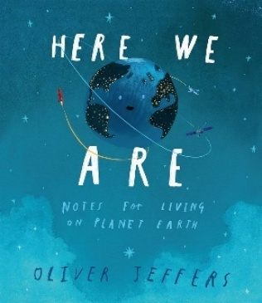
St Thomas’ World Book Day Theme – ‘Here We Are’
This year, we are celebrating World Book Day with a whole-school focus on the beautiful book ‘Here We Are’ by Oliver Jeffers. We will begin the day by sharing the story together, before each class takes part in a creative, hands-on activity inspired by the book’s messages about our planet, people and belonging.
To bring the theme to life, children are invited to dress up as part of “Our Wonderful World” — this could be an animal, plants/flowers, natural features (rain, sun, clouds, oceans etc.), landmarks, people from around the world, or simply themselves. The Our Wonderful World theme keeps costumes simple and low-cost, while giving children the freedom to be creative and celebrate the people, places and nature that make our world special. We’re looking forward to a joyful day of creativity, curiosity and celebration of our world.
As part of World Book Day, every child will also receive a £1 World Book Day book token, which can be used to purchase one of the specially selected £1 books or to receive £1 off another book at participating retailers.

