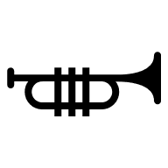
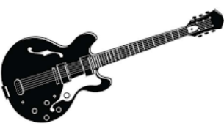
Oldham Music Service
Music Tuition (Initial Interest letter)
Academic Year 2026/7

Next academic year we hope to offer Brass and Guitar tuition to our pupils again provided by the brilliant Oldham Music Service. If your child already has these lessons, please confirm if you wish to continue next year.
For new pupils, if you think your child would enjoy learning to play an instrument, this is a great opportunity to see if they have any musical inclinations. These are private fee-paying lessons for which we are charged by the Music Service.

Expert staff come into school weekly and take small groups of approximately 4 pupils. Your child will be taught to play the guitar/brass instrument, which is supplied by the Music Centre on loan for the year and lessons take place during the school day.

The cost of lessons is £330 a year (£110 per term), payable in three instalments to school via School Gateway and is due at the beginning of each term. This includes loan of the instrument, at least 35 lessons of half an hour a week and school ensemble performances.

Please note, if you sign up to the lessons you will be committing to the full year price. Even if your child no longer wishes to continue during the year, you will still be liable for the full amount.

Learning an instrument is a great skill and has been proven to have a profound and positive effect on brain, social and emotional development. It is also enormous fun!

If you wish your child to be considered for Music Tuition, please return the attached ‘initial interest’ slip to school asap. You are not committed until a contract is signed. Priority is given to existing players.

Oldham Music Service
Music Tuition
Academic Year 2026/7

I would like my child ………………………………………………… to be considered for GUITAR / BRASS tuition commencing in September 2026.

Signed…………………………………………………… Parent/ Carer

