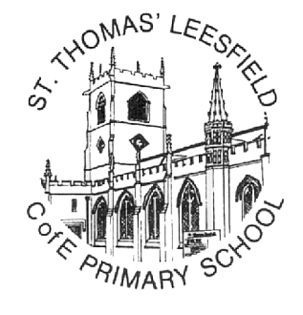
ST THOMAS’ LEESFIELD C OF E PRIMARY
Thomas St, Lees, Oldham, OL4 5AT

Headteacher: Mr J Whittaker

Tel: 0161 770 7400
www.leesfield.oldham.sch.uk

IMPORTANT CHANGES TO FREE SCHOOL MEALS (FSM) FROM SEPTEMBER 2026

Dear Parents and Carers,

The Government is expanding Means Tested Free School Meal eligibility.
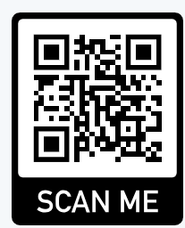
From September 2026, all children in households receiving Universal Credit will be entitled to Free School Meals, not just those with a household income of £7,400 or less.

You must check your entitlement by going to the following website and school will be notified:

https://fsm.lgfl.net/app

If you think you are entitled but cannot find your details/show as not eligible on this website, you can make an application to Oldham MBC via the following link/QR code:
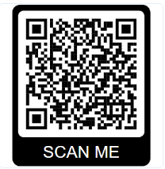
www.oldham.gov.uk/freeschoolmeals

If you currently receive Means Tested FSM, the LA will be in touch with you to let you know if you can continue to receive FSM or if you are no longer eligible. From September, eligibility for FSM will be reviewed annually.

Infant children (Reception, Y1, Y2) will continue to receive free meals as part of the Government’s ‘Universal Infant Free Meals’ programme regardless of this new expansion. However, schools receive funding for FSM children, and we ask all parents to check their entitlement on the London Grid for Learning website (above) to ensure we receive our full grant.

Please complete the form confirming you understand the above and have claimed your entitlement where relevant.

Regards
Mr Whittaker
Please complete and return the reply slip to confirm you have checked your eligibility for Free School Meals.
FREE SCHOOL MEALS - ELIGIBILITY CHECK
(Please return this slip to school)
Child’s Name: _______________________________________
Class: _______________________________________________

Please tick one:
☐ My child is not entitled to Means Tested FSM.
☐ I have checked my eligibility, and my child is eligible for FSM.
☐ I have checked my eligibility, and my child is not eligible for FSM.

☐ I would like school to check my eligibility for FSM.
If you would like school to check your eligibility, please provide the main parent claimant’s full name, DOB and National Insurance number.

Signature: Date: ______________

